
Subject:
AICT
Submitted by:
Amaan Mohsin
Submitted To:
Ms. Hijab Zehra
Department:
Data Science
Registration no:
2025-DS-33

University of Engineering and Technology
Lahore.
TASK# 01
Scholarship Eligibility System
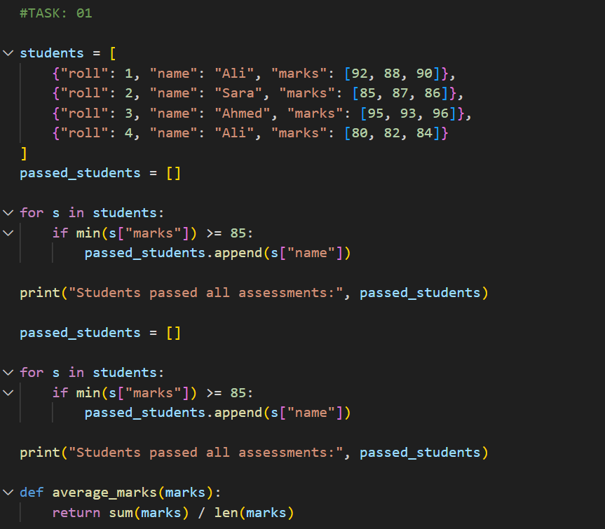
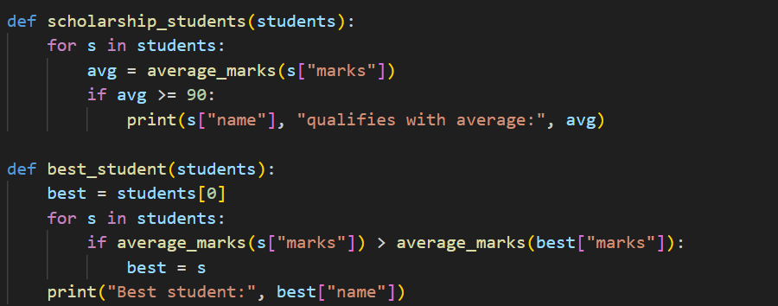
OUTPUT:
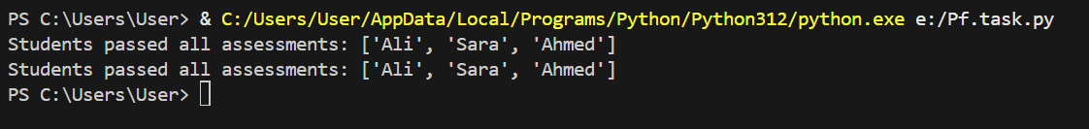
TASK# 02
Warehouse Stock Monitoring
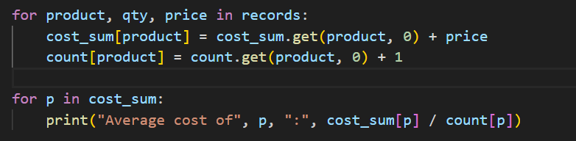
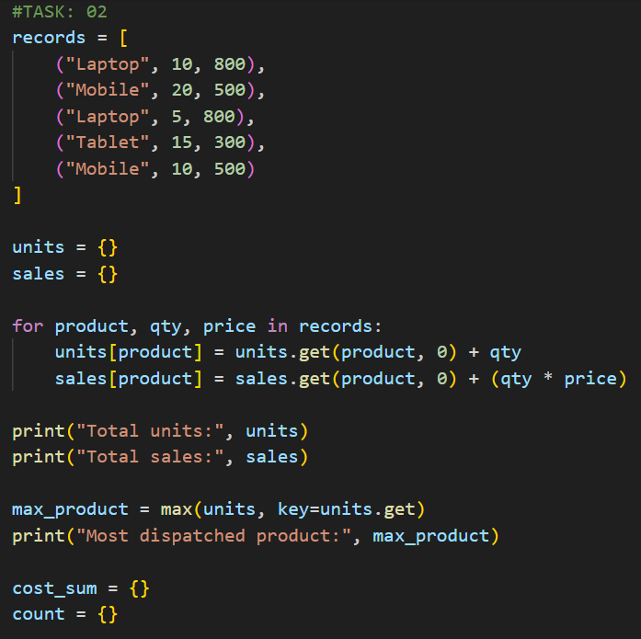

OUTPUT:
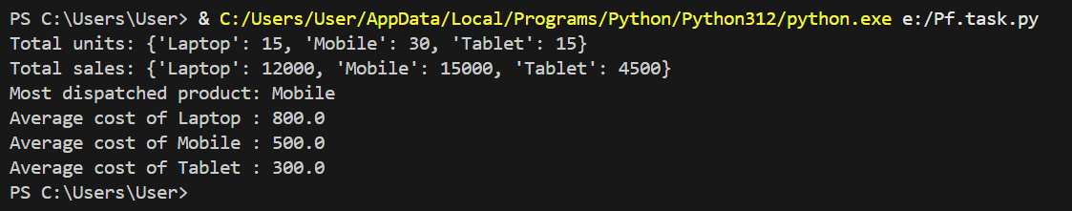
TASK# 03
Employee Performance Review
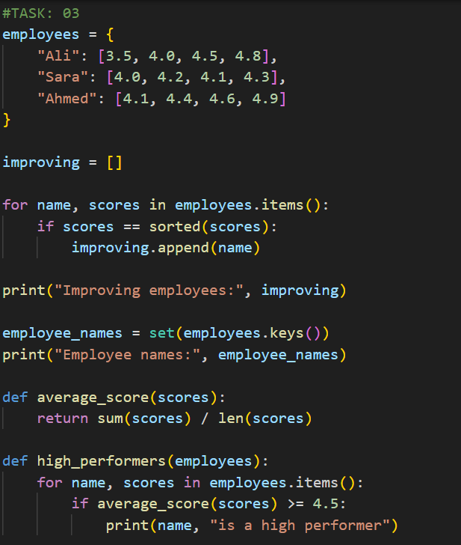
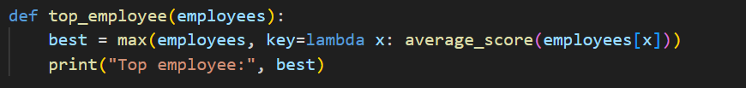
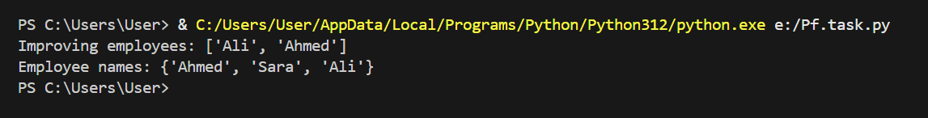
OUTPUT:

TASK# 04
Online Course Sales Summary
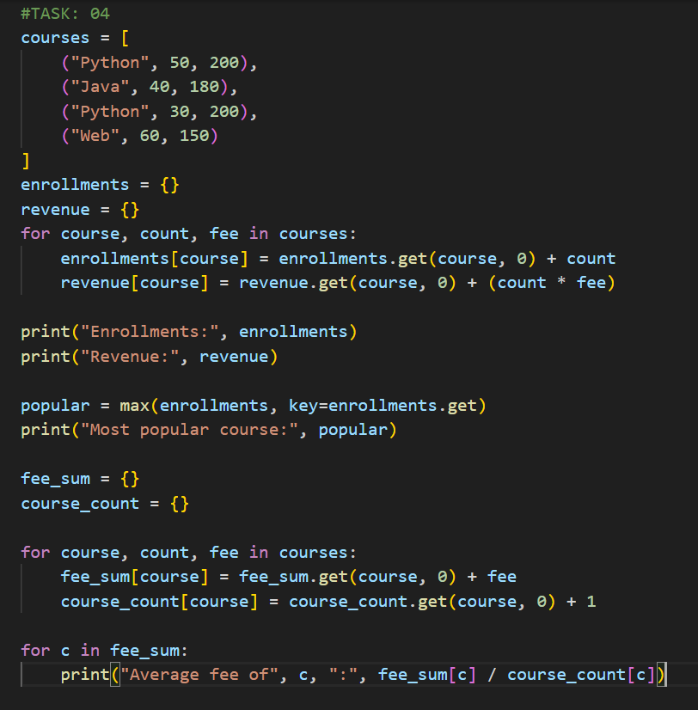
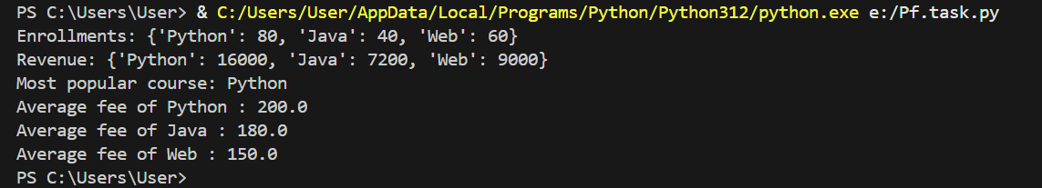
OUTPUT:

